_____________________________________________________________________________________
Journal of Rashid Latif Medical College 2 (2014) 01-03
Original Article


Journal of Rashid Latif Medical College
Original Article |  | Open Access

In Silico docking of piperazin analog for non-small cell lung cancer having mutations in EGFR, ALK, and BRAF proteins.

Sajid Khan*, Faisal Nouroz
Affiliation of Authors:
Department of Bioinformetics, Hazara University Mansehra, Pakistan.
ABSTRACT:___________________________________
Background: Mutations in different genes like EGFR, ALK and BRAF are the sources of non-small cell lung cancer. Mutation of ALK occurs of small inversion on short arm of chromosome 2. The most commonly found EGFR mutations in patients with NSCLC are deletions in exon 29 or in exon 21. Common BRAF transversion mutations occur at exon 15. The missense mutations of BRAF have been detected in exon 11 and exon 15. Objective: The objective of study was to design new chemical compounds to block the targeted sites for receptor proteins present on cells surface, which control the growth or stop the proliferation of cancer cells. Methods: After screening large amount of data, we designed an in silico drug compound for lung cancer that block the mutations in EGFR, ALK and BRAF genes. Results: We suggested a novel compound (7-[2-({6-[4-(chloromethyl) piperazin-l-yl] oxan-3-yl} amino) pyrimidin-5-yl]-octahydropyrano[2,3-c]pyridin-3-ol) to control mutations in EGFR, ALK and BRAF genes. Molecular formula of ligand compound C22H35C1N603 showed promising Lipinski rules of five values having Log P 0.58-1.86, molar refractivity 123.13 ± 0.3 cm³, H bond acceptors and donor 8 and 2 respectively. ALA, LYS, ARG were common interacting residues for EGFR, ALK genes and ALA, GLY were common for ALK, BRAF mutant genes and ligand complex interaction. Conclusion: ALA was common among all interactions that showed less side effects and long resistance against non-small cell lung cancer.

KEY WORD:______

This is an Open Access article and is licensed under a creative commons attribution (4.0 international License)

Introduction  Lung cancer involves uncontrolled cell growth in tissues of the lung, which may lead to metastasis. The majority of primary lung cancers are carcinomas, derived from epithelial cells. Normal DNA gets damaged during normal cell division¹, due to environmental toxic substances such as radon gas, asbestos, cancer causing chemicals like uranium, nickel chromates, coal products, mustard gas, chloromethyl ethers, gasoline and diesel exhaust. The carcinoma spreads from mass of cells and harms other tissues of the lung. After it effects the lung, the whole lung is effected by cancer cells, which cease their normal function^{2,3,4}.  Around 10% to 15% of all lung cancer are small cells lung cancer (SCLC) and 1 of every 8 people are diagnosed with this cancer². The small cell lung carcinoma and non-small cell lung carcinoma (NSCLC) are treated differently; NSCLC is frequently treated with surgery, while SCLC generally responds better to chemotherapy and radiations⁵. Around 7 of 8 people are diagnosed with small cell lung carcinoma, with slower growth rate and are treated differently. NSCLC most commonly results from genetic mutations and is leading cause of deaths of men and women, as 85% of lung cancers are non-small cell lung cancer⁵. Common symptoms of Lung cancer are weight loss, coughing up blood, chest pain, dyspnea, persistent cough, breathlessness, wheezing, hoarseness, shoulder pain and tiredness⁴. The treatments involve the lung cancer surgery, chemotherapy, radiations, combined treatments and targeted therapies. Chemotherapy is achieved by combination of drugs, while targeted therapy is designed to attack cancer cells by attaching or blocking targets that appear on the cell surface. In many cases the targeted compounds may not respond to disease and cancer may revert , drugs produce toxic effects in body and may have severe side effects³.  *Corresponding author email: mrsajid@gmail.com | Mutations in different genes such as epidermal growth factor receptor (EGFR), anaplastic lymphoma kinase (ALK) and B-Raf (BRAF) resulted in non-small cell lung cancer. Mutation of ALK occurs as a result of small inversion within the short arm of chromosome .The most commonly found EGFR mutations in patients with NSCLC are deletion in exon 29 or mutation in exon 21¹. Common BRAF transversion mutations occur at exon 15. The missense mutations of BRAF have been detected in exon 11 and exon 15⁹. EGFR pathway is the main regulator of cell function and cancer development. Up till now EGFR, BRAF and ALK fusion genes are the most widely involved in the development of lung adenocarcinoma and NSCLC ^{1O}.  Material and Methods  Non-small cell lung cancer causing genes were obtained from gene cards database, their target proteins and target compounds were identified. Around 120 ids of EGFR, 55 ids of ALK and 29 ids of BRAF were collected from Protein data bank (PDB) database, Conserved domains of targeted proteins were found by using Scan Prosite and new protein structures were prepared based on conserved domains. We screened large amount of drug databases, analyzed most frequent rings and atoms present in the drugs. New inhibitor compounds were designed consisting of rings and atoms, which were frequently present in selected drugs with the help of ACD / ChemSketch software, the inhibitor molecules , wore docked on targeted proteins.  Bioinformatics tool ACD/ChemSketch was used to design Ligand molecules for proteins, which is the powerful all-purpose chemical drawing and graphics package⁶. Compound was checked for toxicity and ADMET properties⁹ . Then compound was docked to  proteins, and QSAR models were prepared. Inhibitor for EGFR, ALK, and BRAF with chemical name (7-|2-({6- [4-(chloromethyl) piperazin-1-yl] oxan-3-yl}amino) pyrimidin-5-yll -octahydropyrano [2, 3-c] pyridin-3-ol)
has composition C (56.58%), H (7.55%), CI (7.59%), N (18.00%), O (10.28%), and its log P ranges from 0.58-1.86. The compound completely satisfies the Lipinski's rule of five, and has appropriate ADMET properties. The compound 4-(chloromethyl) was designed to block the EGFR, ALK, and BRAF protein activity shown in Fig. 1a. Mutations activate the tyrosine kinase domain of EGFR and were associated with the sensitivity to the small molecules, results in the formation of NSCLC¹. The EGFR protein structure is shown in Fig. 1b.  Somatic mutation in BRAF has to be found in 30% to 40% of non-small cell lung cancer. Common transversion mutations occur at exon 158 in BRAF gene. The missense mutations of BRAF have been detected in exon 11 and exon 15. | BRAF codes for a non-receptor serine/ threonine kinase. The somatic mutation of BRAF in C1786G leads to L596V in the NSCLC cell line¹¹. The BRAF protein is shown in Fig. 1c. Mutation of ALK has to be found in 4% to 5% of non-small cell lung cancer and occurs as a result of small inversion within the short arm of chromosome 2. The ALK undergoes dimerization through the interaction between the coiled coil domain within ALK region of monomers and results in the áctivation of ALK and generates its onco-genetic activity, thus NSCLC occurs in body. The ALK protein structure is shown in Fig. 1d.
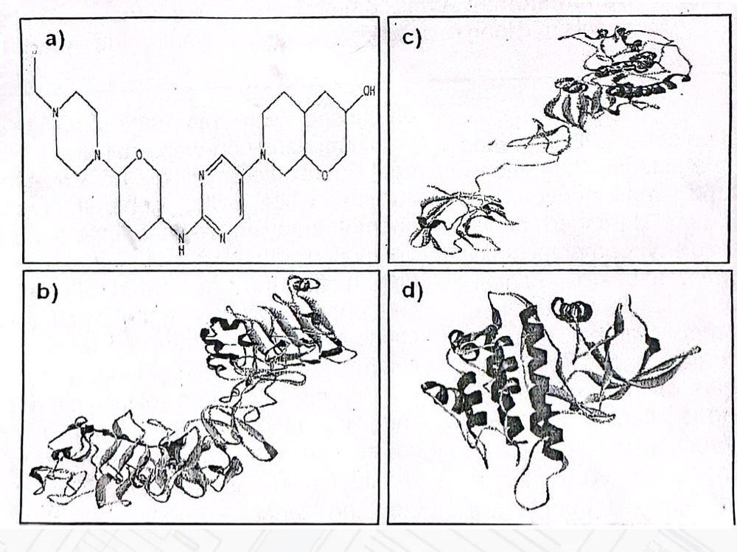
Fig. a): Inhibitor Molecule for EGFR, ALK and BRAF proteins b): EGFR proteins family conserved domain c): BRAF proteins family conserved domain d): ALK conserved domain

Results  Docking and pharmaco-modelling allowed the scientists to screen databases of compounds/proteins and predict the strongest binders based on various scoring functions¹⁰ . QSAR models of complexes were | Determined and an ADMET property was calculated based on the Lipinski’s Rule of Five¹²⁻¹⁴ . The best docking results of EGFR, ALK, BRAF genes and their inhibitor complex are shown in Figs.2-4.

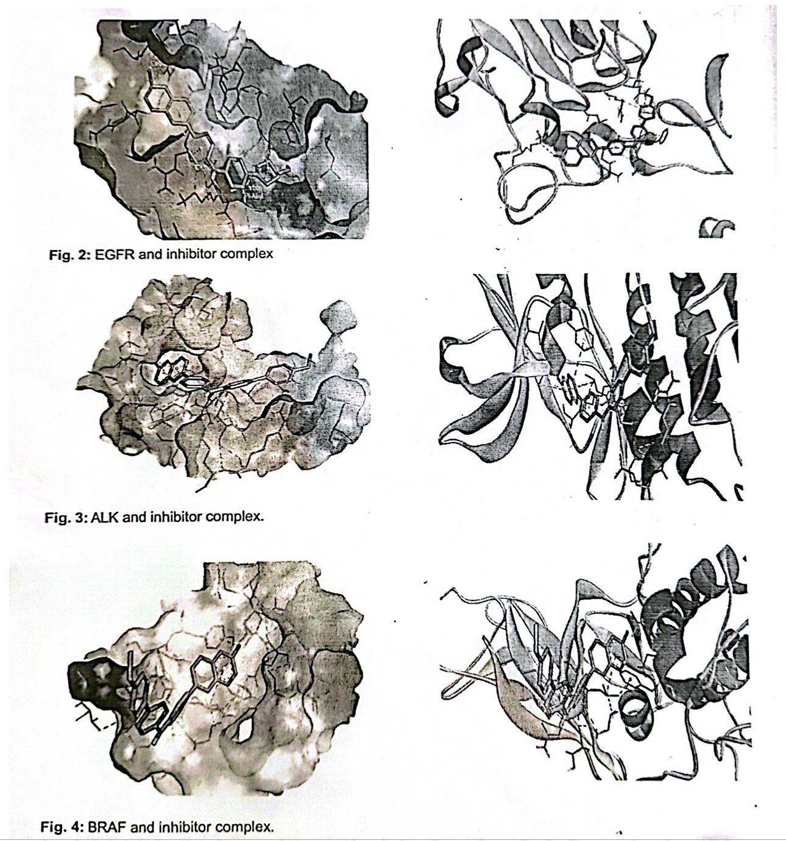

‘
The aspartic acid served as an active site in all targeted proteins studied here. The compound was packed with EGFR protein consisting interacting residues: ALA86, ARG108, ASN110, LEU144, LYS212, ARG252, LYS253, ALA289, EGFR proteins and ligand showed better interactions and best fits in pocket of protein. The compound piperazin docked with ALK and interacting atoms were ARG1120, GLY1121, LEU1122, HIS1124, ALA1126, PHE 1127, ASP1203, LYS1205 and ARG1253. The inhibitors of the high activity group most have these characters, which will effectively inhibit the protein¹⁵.  Docking result of piperazin analog with BRAF showed common interacting residues such as ALA481, YS532, ASN580, and GLY593. A ligand residue is considered to be in binding | site if any of its atoms is within 10 Aº of an atom on the receptor¹⁶. Toxicity levels of compound were predicted by using random drug toxicity prediction servers. The toxicity levels of compounds were in class 6 (harmless and nontoxic).  There were no toxic substance related fragments in structure. Any compound present in class six is nontoxic and may produce side effects if swallowed more than LD50 > 5000 mg/kg. Our designed drug may cause side effects, if given more than 14388 mg/kg. Doses are often given as LD50 values in mg/kg body weight and LD50 is a median lethal dose¹⁴. The toxicity class was defined according to the globally harmonized system of classification of labeling of chemicals. The distribution of dose value is shown in Fig.5.

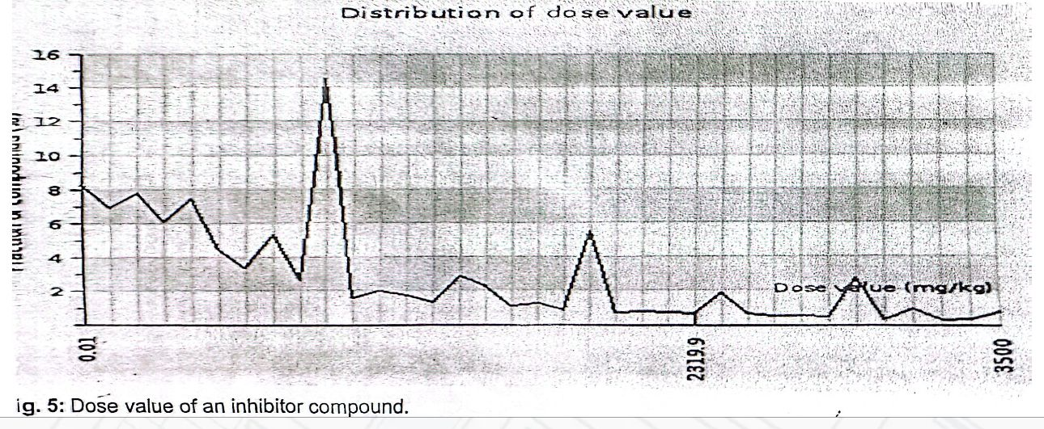

The modification of the molecular structure often leads to drugs with higher molecular weight, more rings, more rotatable bonds and a higher lipophilicity¹⁶. Our ligand compound fulfills all the properties of Lipinski Rules of Five shown in Table 1.  Table: EGFR, ALK, and BRAF inhibitor’s properties based on Lipinski’s rule of 5.  Discussion  The 3-dimensional structure prediction of most genes/proteins proposed that it may be used further to understand the potential mechanism of lung cancer development and role of these proteins in causing abnormalities. It also opens the new gate of drug designing for the better identification of potential drug inhibitor 1.13.  One of the drug designing methods include  building ligand, which is usually referred as receptor-based drug design. The key advantage of such a method was novel structures, not contained in any database, which can be suggested⁸. We have adopted such approach and tried to produce in silico novel ligand compound for our proteins. Molecules designed in silico not only exhibit desired properties but are also amenable to chemical synthesis and have practical value for drug discovery projects¹⁴.  The approved drug in NSCLC was the Gefitini | and Erlotinib for patients having EGFR mutation in NSCLC. Both drugs showed side effects in the form of diarrhea, whizzing and tiredness¹⁵.  Most of the drugs were not currently used as standard treatment for early stages of NSCLC. Physicians used Gefitinib as a first treatment for NSCLC treatment in the past, which was advanced but cause many side effects. ALK patients showed no advantage from the use of Erlotinib¹⁷.To have Gefitinib, the cancer cells must have EGFR receptors¹⁸. It has been shown clearly that the drug Gefitinib has been used to target the human epidermal growth factor receptor. Gefitinib target human EGFR gene for prevention of NSCLC, similarly the present drug inhibitor piperazin analog also target EGFR mutation and produce an energy value of 248 and 268 respectively¹⁹. The Gefitinib do not shows any response to the patients having double mutation of EGFR2. The present designed compound also showed response to double mutations.  Most patients having NSCLC with mutations in the EGFR gene will achieve response to EGFR inhibitors such as Afatinib will fail to improve the overall survival¹⁶. Erlotinib is commonly used to target EGFR mutated non-small cell lung cancer. There are two limitations of Erlotinib; first, it can be used only for single lung cell line. Second, other components vasculature, immunological cells are also affected²¹. Our designed drug piperazin analog will target cancer's specific genes, proteins or the tissue environment that will contribute to survival. They will be promising to personalize cancer treatment. The drug compound confirms interactions with EGFR, ALK and BRAF proteins and blocks their respective abnormal activities.
  Molecular Weight | 446.568 – 467.0047
  H bond acceptors | 8
  H bond donors | 2
  Log P | 0.58- 1.86
  Molar refractivity | 123.13 ± 0.3 cm³
  Molecular formula | C₂₂H₃₅CIN₆O₃
  Rotatable bonds | 5
  No of atoms | 66
  Polar surface area | 86.22 A²
  Molar Volume | 355.8 ± 3.0 cm ³

Conclusion  In our in silico investigation, we used EGFR, ALK, and BRAF proteins, designed the drug and docked with these proteins. The drug compound best fits in the pockets of proteins that showed its stability and confirmed its drug likeness properties. Most of the commercially available drugs violate one or two properties of Lipinski rule of five but our drug fulfills all the properties of this rule. We concluded that our newly designed drug Piperazin analog is better than commercial drugs available in the market. In future, this research work can be further used in clinical trials to test its effectiveness and social benefits.  References  1. David S, Ettinger, et al. • JNCCN. National comprehensive cancer network. Harbor press, New York. 2010; 8(7).  2. Choi YL, Soda M, Yamashita Y, Ueno T, Takashima J, Nakajima T, et al. EML4-ALK mutations in lung cancer that confer resistance to ALK inhibitors. New England Journal of Medicine. 2010; 363(18): 1734-1739  3. Chen P-Y. Computational virtual screening towards designing novel anticancer drugs. Virtual Screening. 2012;91.  4. Toyooka S, Kiura K, Mitsudomi T, others. EGFR mutation and response of lung cancer to gefitinib. N Engl J Med. 2005; 352(20): 2136.  5. National cancer institute (2012). Lung cancer.  National Institute of Health, 12-1553.  6. American Cancer Society. Cancer Facts & Figures  2014, Ga: American Cancer Society; 2014.  7. Baskaran C, Bai VR, Kumaran K, Kumar KM.  Computer aided drug designing (CADD) for EGFR protein Controlling lung cancer. Ann Biol Res. 2012;  3(4): 1815-1820. | 8. Ramani RG, Jacob SG. Improved Classification of Lung Cancer Tumors Based on Structural and Physicochemical Properties of Proteins Using Data Mining Models, PLoS One. 2013; 8(3).  9. Chase SM, Crabtree BF, Stewart EE, Nutting PA, Miller WL, Stange KC, et al. Coaching strategies for enhancing practice transformation. Fam Pract.  2014;32(1): 1-7.0  10. Zahra E, SN, Khattak NA, Mir A. Comparative modeling and docking studies of p16ink4/Cyclin D1/Rb pathway genes in lung cancer revealed functionally interactive residue of RB1 and its functional partner E2F1. Theor Biol Med Model,  2013; 10(1): 1.  11. Suleiman AA, Nogová L, Fuhr U. Modeling NSCLC Progression: Recent Advances and Opportunities Available. AAPS J. 2013; 15(2):542-50.  12. Marchetti A, Felicioni L, Malatesta S, Sciarrotta MG, Guetti L, Chella A, et al. Clinical Features and Outcome of Patients With Non-Small-Cell Lung Cancer Harboring BRAF Mutations. JCO. 2011; 29(26): 3574-9.  13. Dai X, Tan C. Combination of MicroRNA Therapeutics with Small-molecule Anticancer Drugs: Mechanism of Action and Co-delivery Nanocarriers. Adv Drug Deliv Rev. 2014.  14. Hammerman PS, Sos ML, Ramos AH, Xu C, DuttA, Zhou W, et al. Mutations in the DDR2 kinase gene identifies a novel therapeutic target in squamous cell lung cancer. Cancer Discov. 2011; 1(1):78-89.  15. Riquet M, Arame A, Fabre E. N2 involvement in lung cancer: the Danaïdes' barrel. Eur J Cardiothorac  Surg. 2014.  16. Hammerman PS, Sos ML, Ramos AH, Xu C, DuttA, Zhou W, et al. Mutations in DDR2 kinase gene identify a novel therapeutic target in squamous cell lung cancer Discov.2011; 1(1): 78-89
17. Sculier J-P, Berghmans T, Meert A-P. Advances in target therapy in lung cancer. Eur Respir Rev. 2015  Mar 1;24(135):23-9.  18. Kobayashi S, Boggon T.J, Dayaram T, Jänne, P.A, Kocher O, Meyerson M, Halmos B. (2005). EGFR mutation and resistance of non-small-cell lung cancer to gefitinib. New Engl J Med. 352(8),  786-792.  19. Heigener, D. F. The Use of Biomarkers to Guide  Treatment Decisions in Non-small-cell Lung Cancer. Clin Chem, 2012; 30(6). | 20. Chauhan JS, Dhanda SK, Singia D, Agarwal SM, Raghava GPS. QSAR-Based Models for Designing Quinazoline/Imidazothiazoles/Pyrazolopyrimidines  Based Inhibitors against Wild and Mutant EGFR.  PLoS One. 2014; 9(7).  21. Ammi R, De Waele J, Willemen Y, Van Brussel I, Schrijvers DM, Lion E, et al. Poly(I:C) as cancer vaccine adjuvant: Knocking on the door of medical breakthroughs. Pharmacol Ther. 2014.

