__________________________________________________________________________________
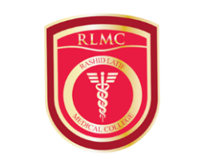
Original Article

Journal of Rashid Latif Medical College

Original Article |  | Open Access

A Study on Seroprevalence of ABO Blood groups in Lahore, Pakistan
Sidra Shaheen', Faisal Nouroz¹*, Ghulam Mujtaba², Shumaila Noreen³ and Muhammad Farooq⁴
Affiliations of Authors:
¹Department of Bioinformatics, Hazara University Mansehra, Pakistan
²Institute of Nuclear Medicine and Oncology Lahore (INMOL), Pakistan
³Department of Zoology, University of Peshawar, Pakistan
⁴Department of Biochemistry, Hazara University Mansehra, Pakistan

KEY WORDS: | ABSTRACT  Objective: The blood group system (ABO) and Rhesus genes (Rh) phenotypes vary widely between populations and ethno-geographical areas.The present study aimed to determine the distribution of ABO and Rh groups in a subset of population from Lahore, Pakistan. Design & Methodology: The study included 1000 subjects (76.1% males and 23.9% females) from INMOL hospital, Lahore. Forward grouping was performed by using antigen-antibody agglutination method. Results: The distribution of phenotypes in the total sample was 23.9%, 35.2%, 8.8% and 32.1% for groups A, B, AB and O respectively. However, the seroprevalence of Rh positive (R) and Rh negative (r) was 91.7% and 8.3%, respectively. Conclusion: It was concluded that blood group B had highest prevalence and AB was the least frequent in population from Lahore and surroundings. This data may be helpful in keeping record for the management of availability of blood for crises. Also, it represents the variety in allele distribution in this population.
This is an Open Access article and is licensed under a creative commons attribution (4.0 international License)

Introduction:
Blood is a vital physiological fluid (plasma and blood cells), which h elps in circulation of enzymes, important nutrients, hormones and oxygen to all over the body. Among blood cells, the membrane of human red blood cells consists of various types of polysaccharide antigens, known as agglutinogen which plays important role in blood grouping'. Blood grouping is important in different genetic, clinical, diagnostic and forensic studies. Additionally, blood transfusion helps to decrease the rate of morbidity and mortality as well as population migration patterns ^{2,3}. A, B, and O blood group types were discovered by Landsteiner in 1901, while the blood group AB was discovered in 1902 by Desterllo and Sturli⁴. The Rhesus (Rh) blood group was identified by Landsteiner and Weiner as an additional factor other than ABO (1941)⁵. The ABO system has been distributed into four blood groups types A, B, O and AB, while Rh positive and Rh negative in Rh system depends on presence or absence of A and B surface antigens ⁶.
A and B blood group exhibited A and B type antigens and O blood group exhibit neither type A nor type B antigens. In addition, plasma from A blood group comprise of anti-B antibodies, which act against B type antigens, whereas plasma from B type blood group consist of anti-A type antibodies, acting against A type antigens. O type blood has A and B antibodies while AB type has neither type of antibody. A, B and O antigens are similar, instead of blood group A has an extra sugar (N-acetylgalactosamine), group B has galactose while group O possesses none of them⁷. The Rh antigen is located at the surface of red blood cells (RBCs). determining the Rh positive or Rh negative factor based on its presence or absence respectively. The ABO and Rh blood group data is extremely helpful in organ transplantation and blood transfusion ^{8,9}.
The blood groups are inherited from both parents. A single gene controlling ABO blood types is located on long arm of chromosome number 9 with three alleles.
The allele I^{A}, I^{B} are dominant over allele l°, representing important dominance relationship (co-dominance), which means that child can have AB blood type when parents have type A and B blood group and if parents are heterozygous (I^{A} I°, I^{B} I°), then the child will have the chance to develop O type blood group (I° I°). Two allele, R (Rh positive) and r (Rh negative) represents the inheritance of Rh blood types ¹⁰.
The worldwide prevalence of ABO and Rh factor is different. In African-American ABO blood types, the prevalence of group O is 46%, group A, B and AB has 27%, 20% and 7% respectively. Among Caucasians in United State, the prevalence of blood group O, A, B and AB is 47%, 41%, 9% and 3% respectively. Similarly, the prevalence of blood type O, A, B and AB in Western European is 46%, 42%, 9% and 3% ^{11,12}.Furthermore, in Rh grouping, 85% of Caucasians are Rh positive and 15% are Rh negative. In African-Americans about 95% people are Rh positive, whereas indigenous Africans are nearly 100% Rh positive ^{1,13}.The present study was conducted to detect the ABO blood group prevalence in population of Lahore, Punjab, Pakistan.
Material and Methods
Subjects and blood collection
Collectively 1000 subjects were screened; of which about 239 were the females and remaining 761 were the males. The screening was performed at clinical laboratory of Institute of Nuclear Medicine and Oncology Lahore (INMOL), Pakistan during October, 2011 to December, 2012. The subjects were from various urban and rural areas of Lahore, who were thoroughly interviewed before screening for their general particulars such as sex, address etc to keep records. Information was also collected for their previous blood record such as blood donation, diagnostics or transfusion. With the use of a disposable syringe, a 2.0 ml blood sample without adding anticoagulant was drawn from Antecubital vein of the subject. The blood was immediately transferred to a tube containing ethylene diamine tetra acetic acid (EDTA). The antisera were obtained from Biotech Laboratories (BIOTEC Laboratories Ltd, Suffolk, UK).
Blood typing
Forward grouping was performed by using antigen-antibody agglutination method ¹⁴. In case of incomprehensible or the doubtful results, the tube method was adopted for blood grouping along with reverse grouping, using patient's serum and known A, B and O cells ¹⁵.The ABO and Rh blood grouping was performed by white tile or slide method with three columns labeled with A, B and O respectively. A drop of anti-A, anti-B and anti-D anti sera was placed in each column and mixed blood samples thoroughly by a glass rod. After few minutes, the mixture was examined for agglutination, which indicates the presence of A, B and O blood groups. The blood group is considered O, when no agglutination was observed in anti-A or anti-B mixture. While in anti-D column, if agglutination occurred, than blood was considered as Rh positive, but if no agglutination detected, the blood is treated as Rh negative ¹⁶.
Results and Discussion
A total of 1000 blood samples were taken to study the prevalence of different blood group alleles from Lahore (Punjab) population of Pakistan. Of these, 761 (76.1%) samples were male subjects, while other 239 (23.9%) were female. The highest allele frequency was found for B type blood group (35.2%), followed by O (32.1%), A (23.9%) and AB (8.8%) types (Table 1). The Rh allele frequency was also studied, which revealed that about 91.7% blood groups have Rh factor, while only 8.3% are Rh Negative (Table 1) Moreover, the same pattern of blood group allele prevalence was observed in both males and females.
Table 2 and Figure 1 represent phenotypic frequency of ABO blood groups, with gender distribution under study. The distribution of phenotypes in the total sample was 0.23, 0.35, 0.08 and 0.32 for group A, B, AB and O respectively. Phenotypically B group was dominant in overall samples and AB was very rare. However O blood type was most prevalent among males and B group was highest in females.
Various blood group systems exist in human population among which the prevalent is the ABO blood group. The diversity of blood group is because of factors like genetic drift, migration, allele selection and other random effects. The polymorphism in these blood groups helps in considering the similarities and difference in population ¹⁷. There are few studies in Pakistan that targeted the estimation of blood group frequency in the local population of various regions. Among these, there are only few which utilized a saturated population. In view of this fact, a sample size of 1000 subjects was isolated from the population of Lahore, Punjab. The distribution of blood groups was found to be 23.9%, 35.2%, 8.8%, 32. 1% for blood group A, B, AB and O. The frequency for allele A, B, AB and O were calculated to be 0.23, 0.35, 0.08 and 0.32 respectively (Table 1, 2). At Rh locus, 91.7% of the subjects were Rh positive while 8.3% were Rh negative and the frequency of 'd' allele was calculated to be 0.299. In the present study, blood group B is most prevalent in overall samples and AB is the rare type. However, O blood group has the highest frequency in males whereas in females, blood group B remains highest in occurrence (Figure 1). The data shows a general trend of prevalence as B>O>A>AB and the allelic frequencies are in order of O>B>A. The present study doesn't deviate much from those which have been recorded in the past from other Pakistani regions ¹⁷.
By comparing our results with previous findings from other countries, we deduce that the AB blood type is rare in all populations as observed in the present study. A study was conducted in Jammu and Kashmir, where blood group B was the most prevalent (36.6%) as compared to O (35%), A (21.4%) and AB (7%) ¹⁸. Blood type O was the most common in Bangalore, India instead of B (29.95%), A (23.85%) and AB (6.37%) ¹⁹.Blood group B (32.40%) was reported to be the most common in Swat area of Pakistan, as compared to O (29.10%), A (27.92%) and AB (10.58%) blood types ²⁰. Blood group O (40.6%) was prevalent in Bangladesh, in comparison to A (26.6%), B (23.2%) and AB (9.6%) ²¹. Furthermore, O is most prevalent among United States, Syrian Arab, Palestine and Asia, while AB was the least common blood type. All over the world, Rh (D) positive is most common as compared to Rh (D) negative²².
Among population from Pakistan, 87.1%-90% blood groups are related to Rh positive ²⁰.
Similar percentage was observed for Bangladesh population having 96.8% Rh positive blood group types ²³.Globally, the prevalence of blood groups are different as reported in different Provinces of Pakistan. These blood types vary due to environmental and genetic factors ²⁴. The data may be helpful for health planners while making efforts to face the future health challenges in the region.Conclusively, the data may be helpful for record keeping and managing availability of blood during calamities. Moreover, associative studies may serve as grounds for risk assessment of various diseases in a population.

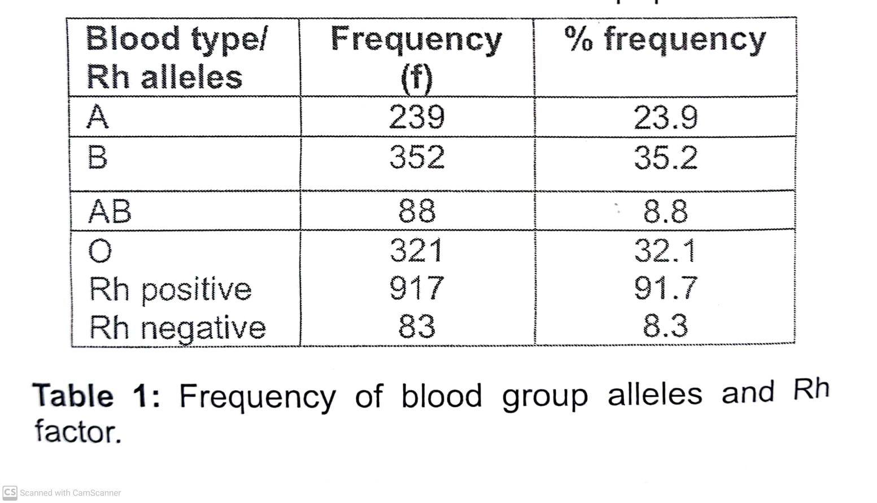

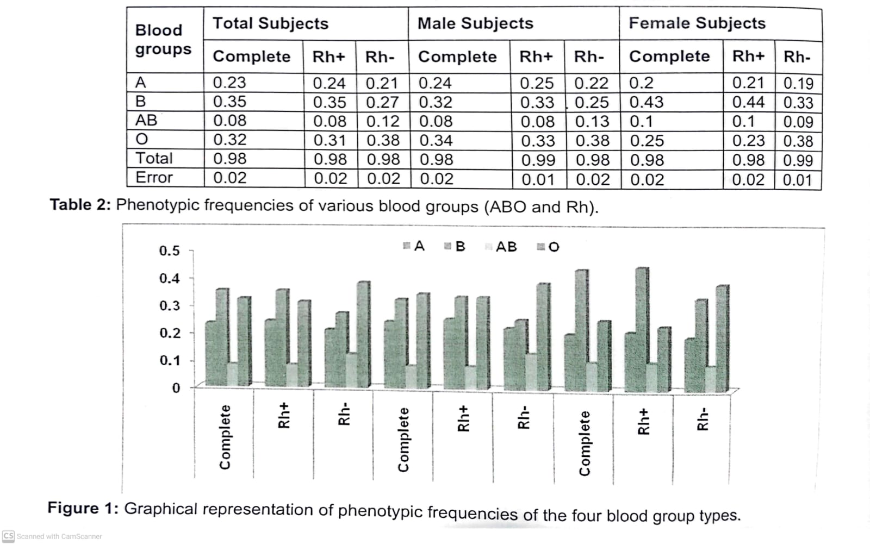

Conclusions
Populations have different ABO blood group allelic frequencies based on respective ethnic differences and variable gene pool. The present study concluded that the order of prevalence of various blood groups is B>O>A>AB with 91.7% Rh positive and 8.3% Rh negative factor indicating a strong dominance of Rh positive allele in Lahore population. We found phenotypic frequencies i.e. A = 0.23, B = 0.35, AB = 0.08 and 0 = 0.32. This data will be helpful for blood collection centers to keep the stock of most demanded blood types.
Acknowledgements
We are grateful to all staff from Centre for Research in Molecular Medicine (CRiMM), University of Lahore for their consistent support and technical guidance during this work. We are thankful to all Doctors and Scientists of Institute of Nuclear Medicines and Oncology, Lahore (INMOL) for providing blood samples as well as technical assistance. Special thanks to Farzana Bibi and Zainab Bukhari, Department of Bioinformatics, Hazara University Mansehra for assisting in preparation of this manuscript.
References
1. Ganong WF. Review of medical physiology. 17" edition. Prentice Hall International Inc: London. 1995:487-489.
2. Pennap G, Envoh E and Igbawua I. Frequency distribution of hemoglobin variants, ABO and rhesus blood groups among students of African descent. Brit.
Microbiol. Res. J. 2011; 1:33-40.
3. Mondal B, Maiti S, Biswas BK, Ghosh D and Paul S.
Prevalence of hemoglobinopathy, ABO and rhesus blood groups in rural areas of West Bengal, India. J Res Med Sci. 2012; 17: 772-776.
4. Garratty G. Relationship of blood groups to disease:
Do blood group antigens have a biological role? Rev Mex Seguro Soc. 2005; 43: 113-121.
5. Rahman M and Lodhi Y. Frequency of ABO and rhesus blood groups in blood donors in Punjab. Pak J Med
Sci. 2004; 20: 315-318
6. Nishi K, Gupta NK and Sharma SC. Study on the incidence of hypertension and migraine in ABO blood groups. J of Biol Sci. 2012; 1: 12-16.
7. Criswell D. ABO blood and human origins. Institute for creation research. <http://www.icr.org/article/abo
blood human origins/>. 2014; 5-24.
8. Eweidah MH, Rahiman S, Ali MDH, Al-Shamary AMD Distribution of ABO and Resus blood groups in Al Jouf province of Saudi Arabia. Anthropologist. 2011;
13: 99-102.
9. lyiola OA, Igunnugbemi 0O, Bello OG. Gene frequencies of ABO and Rh (D) blood group alleles in Lagos, South-West Nigeria. The Egyptian J Med Human Gen. 2012; 13: 147-153.
10. Yazar M, Olsson M, Palcic M. The cis-AB blood group phenotype: Fundamental lessons in glycobiology.
Transfus Med Rev. 2006; 20: 207-217.
11. Pramanik T and Pramanik S. Distribution of ABO and Rh blood groups in Nepalese students. A report. East Mediterr Health J. 2000; 6: 156-158.
12. Adeyemo OA and Soboyejo OB. Frequency distribution of ABO, Rh blood groups and blood genotypes among the cell biology and genetics students of University of Lagos Nigeria. Afr J Biotechnol. 2006; 5: 2062-2065.
13. Guyton AC and Hall JE. Blood cells and blood clotting:
Blood groups. Medical physiology. 11" edition.
Philsdelphia (PA): WB Saunders Company. 2005; 11:
458-459.
14. Vujhini SK, Sanagapati PRR, Kandukuri M. Frequency and distribution of blood donors of a tertiary care hospital in rangareddy district of Telanaga State, India.
Med. Sci. 2014; 10: 95-98.
15. Garg P, Upadhyay S, Chufal SS, Hasan Y, Tayal I.
Prevalence of ABO and Resus blood donors: A study from a tertiary care teaching hospital of Kuman region of Uttarakhand. J. of Clin. Dia. Res. 2014; 8: FC16-FC19.
16. Nagariya SA. Allelic frequency of ABO blood group typing and Rh (D) factor in Muslim and Hindu caste of Amravati district (Maharastra). Intl Res J Sci and Eng.
2013; 1: 100-102.
17. Khalid M and Qureshi MA. Frequency of blood group antigens and corresponding alleles in the population of Mirpur, Azad Jamu Kashmir, Pakistan. J Ani PI Sci.
2006; 16: 3-4.
18. Khan MN, Khaliq I, Bakhsh A, Akhtar MS, Amin-ud-Din
M. Distribution of ABO and Rh (D) blood groups in the population of Poonch district, Azad Jammu and Kashmir. East Mediterr Health J. 2009; 15: 717-721.
19. Periyavan S, Sangeetha SK, Marimuthu P, Manjunath BK, Seema DM. Distribution of ABO and rhesus-D blood groups in and around Bangalore. Asian J Transfus Sci. 2010; 4:41.
20. Khattak ID, Khan TM, Khan P, Shah SM, Khattak ST, Ali A. Frequency of ABO and Rh blood groups in district Swat, Pakistan. JAyub Med Col. 2008; 20: 127-129
21. Talukder SI and Das RK. Distribution of ABO and Rh blood groups among blood donors of Bangladesh.
Dinajpur Med Col J. 2010; 3: 55-58.
22. Canadian Blood Services-Societe canadienne du sang. "Types and Rh system, Canadian Blood Services". Retrieved. 2010: 11-19.
23. Anees M and Mirza MS. Distribution of ABO and Rh blood group alleles in Gujrat region of Punjab, Pakistan. Proc Pakistan Acad Sci. 2005; 42: 233-238.
24. Khan MU, Bashir MW, Rehman R, Kiani RA.
Frequency of ABO and Rh (D) blood donors in Lahore, Pakistan. Int JAdv Biol Biom Res. 2014; 2: 597-600.

